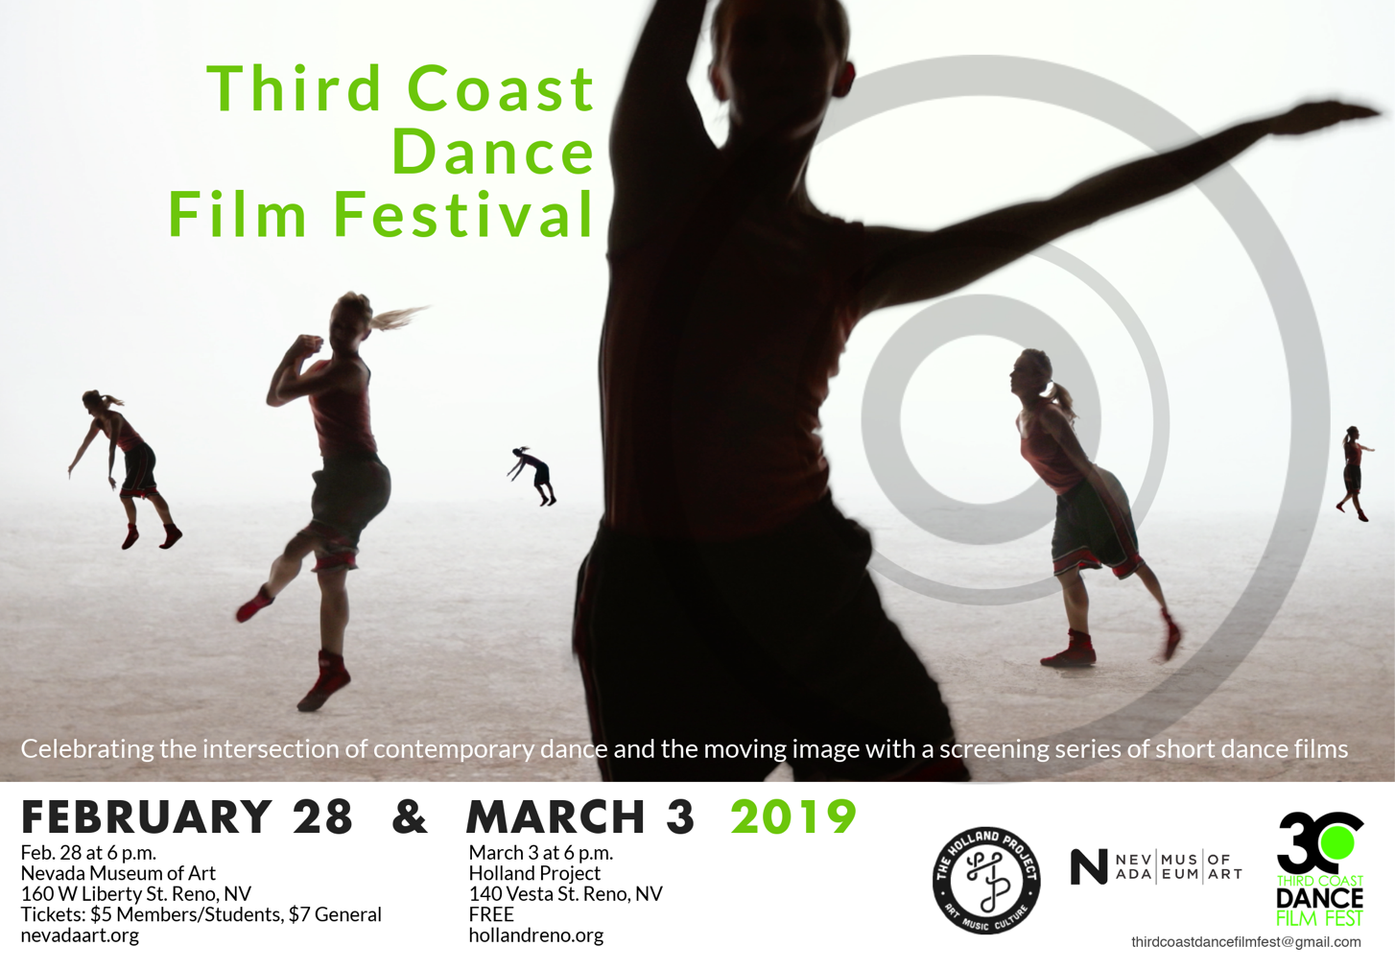

Currently in its ninth year, the Third Coast Dance Film Festival celebrates the intersection of
contemporary dance and the moving image with a screening series of short dance films.

2019 Third Coast Dance Film Festival Curators: Charli Brissey, Ellen Duffy, and Rosie Trump.
The festival screens in Reno, NV Feb. 28 and March 3, and will tour the US through the summer.

A special thank you to Alana Berglund, Ellen Duffy, and all of the filmmakers.

http://thirdcoastdancefilmfestival.wordpress.com
thirdcoastdancefilmfest@gmail.com
Like us on Facebook!

2019 Third Coast Dance Film Festival Program | The Holland Project

Floating Chronologies, 2017 (USA)
Directors & Producers: Mary Fitzgerald & Dmitri von Klein | Performers: Danielle Feinberg, Mary Fitzgerald, Liliana Gomez, Sydney Jackson, Shauna Meredith, Taimy Miranda, Nicole Olson | Music: Casey Farina
Description: Set in the stunning and timeless landscape of the Painted Desert, the piece offers a poetic look at the body's shifts in strength and vulnerability across three generations of women.

STAY, 2018 (USA)
Director & Choreographer: Pam Kuntz | Producer: Kuntz and Company | Cinematographer: Angela Kiser | Music: Michael Wall | Performers: Evyn Bartlett, Cara Congelli
Description: A young couple struggles with their long term passionate relationship.

Tete de courbe, 2018 (Russia)
Director: Lada Iskanderova | Choreographer & Performer: Julia Cherepnina | Music: Camille Au Port
Description: The woman returns home. But the corridor begins to spin and wobble, preventing her.

TRIANGULATE, 2018 (Canada & South Africa)
Directors: Cydney Eva Pattern, Costa Besa | Videographers: Jason Bempong, Nhlanhla Gcasbashe, Kimberly Gonzalez, Cebo Nxumalo, Cydney Eva Pattern, Han Pham | Performers: South Africa: Lorin SoKool, TJ Jali, Nipho Hurd, Costa Besta, LexLafoy, Cydney Eva Pattern. Canada: Costa Besta, Cydney Eva Pattern. Immigrant Lessons: Kevin Fraser, Alyssa Amarshi, Jason Bempong, Marisa Gold, Josh Ongcol, Sophia Gamboa, Sharon Lee | Music: Nipho Hurd,
Lex LaFoy, Costa Besta, Gavin Bowden
Description: Filmed within three cities: Durban South Africa on Zulu Land, this film brought together 21 diverse artists as they explore connecting the Mind, Body and Soul through dance, visual art, self-expression and cross-cultural exchange.

LADIA, 2018 (USA)
Director & Producer: Alvaro Congosto | Choreographer: Sandra Kramerova | Performer: Sandra Kramerova |
Music: Jon Lloyd
Description: LADIA is an experimental dance film where pain, exhaustion and will power become part of a female solo fight/dance.

Palace of the Infinite, 2017 (USA)
Director, Choreographer & Producer: Kathy Rose | Performers: Kathy Rose, Katarina Poljak, Liang Yu, Su Rim Kim
Description: …a rich tapestry of Orchid beings… haunting the Palace of the Mind… the breathing rain whispers.

Salt Water, 2017 (USA)
Director & Choreographer: Abe Abraham
Description: Dance-film set to the seismographic recordings of the earth's vibrations.

Digital Afterlives, 2018 (Australia)
Directors & Producers: Richard James Allen, Karen Pearlman | Choreographer & Performers: Richard James Allen | Music: Franz Liszt
Description: An existential disaster comedy.

