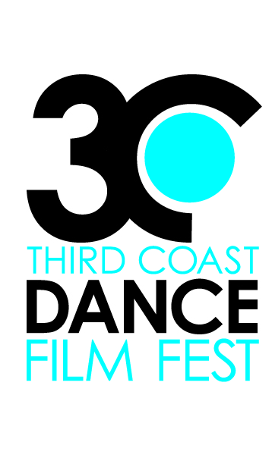
FOR IMMEDIATE DISTRIBUTION

August 22, 2012

Media contact: Rosie Trump

thirdcoastdancefilmfest@gmail.com

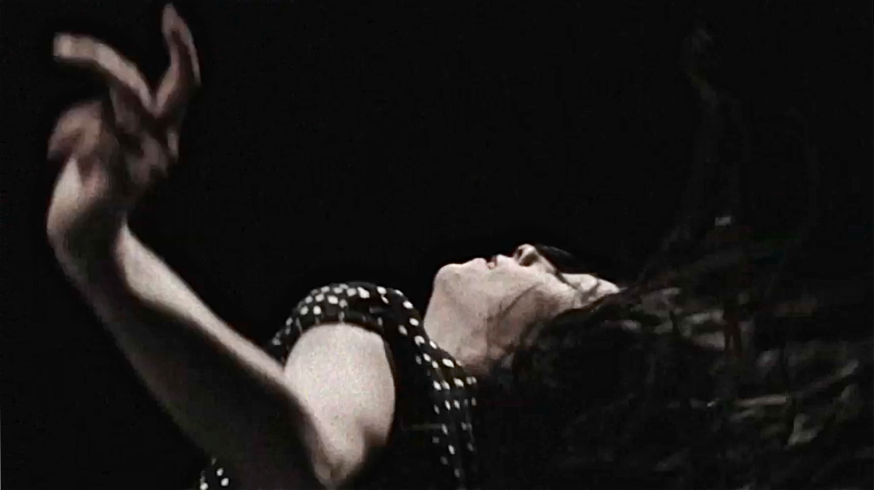
still frame from the film “Errances” by Audrey Bergeron
2012 Third Coast Dance Film Festival Enters Third Season
Houston, TX.- Now in it’s third season, The Third Coast Dance Festival returns on September 15 and 16, 7 p.m. at Rice University Cinema. Curated by Rosie Trump and Lydia Hance, The Third Coast Dance Film Festival celebrates the intersection of contemporary dance and the moving image with a screening series of short dance films. This year’s festival features three Houston based dance filmmakers: Ashley Horn, Lynn Lane and Lindsey Sarah Thompson.
The festival is presenting twenty-one film shorts, including five international films from Australia, Canada, Finland, Russia and Spain. Co-curator and festival founder Rosie Trump notes, “The festival keeps growing each year, attracting stronger submissions from around the world.”
The films will be divided between Program A on September 15 and Program B on September 16, with the Houston based films screening both nights. Attending both screenings ensures the audience sees all twenty-one films.
- more -
There is something for everyone Trump explains, “Some of the films are very emotional, some are funny and clever, but one of the most striking features of these dance films are the locations! Many take place in the most beautiful or unusual places.” Audiences will see dancing on rooftops, underwater, in bathroom stalls, in movie theaters, through city streets and more.
Houston choreographer and dancer, Ashley Horn has been featured in the festival twice before. This year her film, Jazzland, was filmed in the abandoned landscape of a New Orleans theme park flooded by Hurricane Katrina. It also features an original score by Houston’s improvisational pianist Robert Pearson.
Lindsey Sarah Thompson, a Houston dancer and artist, created the film permission in the aftermath of a home break in experience. With her film, she confronts issues of personal space, ownership and voyeurism to ask: Where is "home" and what permissions accompanies that space?
The Third Coast Dance Film Festival is Houston’s premier event for dance on film. The 2011 festival went on tour, screening at the Kaleidoscope Arts Festival outside of Pittsburgh, PA. Founded in 2010 by Rosie Trump, the 2012 festival is co-curated by Rosie Trump and Lydia Hance. Lydia Hance is the artistic director of Houston company Frame Dance Productions and has had two of her films previously featured in the Third Coast Dance Film Festival.
The third annual Third Coast Dance Film Festival opens on September 15 and 16, 2012 at Rice University Cinema on Rice University campus, located off of entrance 8, Rice University, 6100 Main St, Houston, TX 77005. This event is free and open to the public. For more information, contact Rosie Trump at thirdcoastdancefilmfest@gmail.com or visit http://thirdcoastdancefilmfestival.wordpress.com.
- end-

