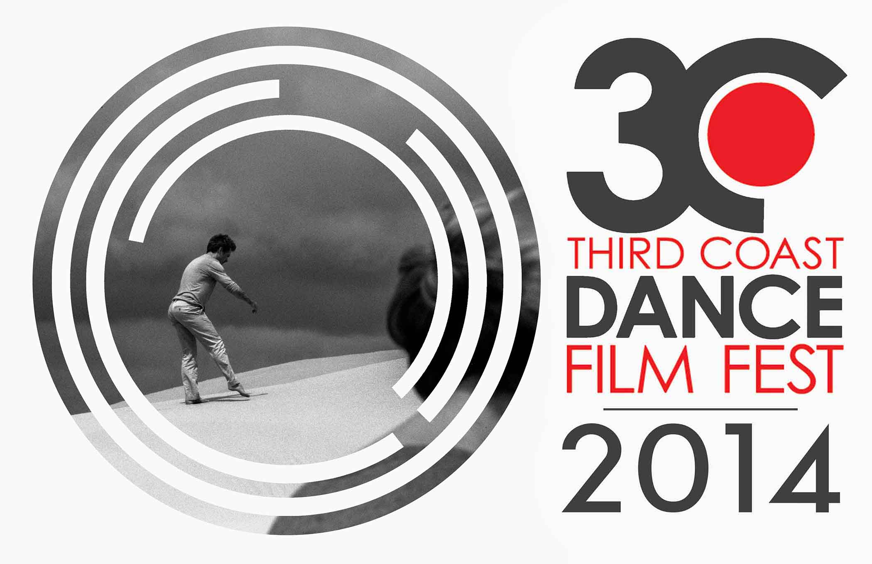

Currently in its fourth season, the Third Coast Dance Film Festival celebrates the intersection of contemporary dance and the moving image with a screening series of short dance films. The 2014 Third Coast Dance Film Festival is screening nineteen film shorts, including five international films from Canada, Germany, Israel, Mexico, Norway, South Korea, and Spain.
The festival is showcasing 3 World, and 6 USA premieres.

The 2014 festival premiered in Houston, TX in October and continues touring to Reno, NV in February 2015 and Slippery Rock, PA in April 2015.

Third Coast Dance Film Festival Curators: Rosie Trump, Lydia Hance, Ashley Horn, and
Rebecca Salzar. The festival was founded in 2010 by Rosie Trump.

A special thank you to Jennifer Keller, Josie Luciano, Abrie Parrish,
the Slippery Rock University Department of Dance
and all of the filmmakers.

http://thirdcoastdancefilmfestival.wordpress.com
thirdcoastdancefilmfest@gmail.com
Like us on facebook!

The Third Coast Dance Film Festival Touring Program
Presented by the Kaleidoscope Arts Festival
April 22, 2015 from 4:30-5:30 pm

DRAWING BLANK, 2012 (Canada)
Director: Stephan Verna | Choreographer & Dancer: Emily Honegger | Director of Photography: Bill Kerrigan | Sound: David Drury | Special Effects Coordinator: Alexis Trepanier | Stop-Motion Painting: Gene Pendon
Description: Drawing Blank is a dream-like story of impermanence told through dance and stop-motion painting. The main character discovers a magical property inside a discarded ink sketch.

Sombran los motivos, 2014 (Spain)
Director, Sound, Camera & Editor: Félix Vázquez | Dancer: Leonor Leal

Repercussions, 2014 (USA)
Director, Choreographer, Cinematographer & Performer: Emily Robison | Music: Suum Cuique
Description: After a series of childhood distresses, the artist now faces various psychological obstacles.

Nearby Far, 2013 (USA)
Directors, Choreographers & Performers: Mary Fitzgerald and Brad Garner | Music: Chet Udell | Director of Photography: Dmitri von Klein | Editing: Mary Fitzgerald
Description: Set in the gorgeous landscape of the Oregon Dunes, Nearby Far explores the endurance of a relationship over the spans of time, space and distance. The film is shot in monochrome, and uses a time lapse process.

What’s What, 2014 (USA) Best of Festival Award Winner
Directors & Choreographers: Charli Brissey & Courtney Harris | Lighting Design: Michael Jarret | Music: The Savannah Havoy Band
Description: This short dance extravaganza tips its hat to the history of gender-bending performance and early filmmaking.

Henka Dance, 2013 (UK)
Director: Ollie Murray | Production Design: Rohan Wadham | Cinematography: Jim Jolliffe | Dancer: Fukiko Takese | Editor: Ollie Murray| Music: Jessica Dasshesier | Visual FX: Alex Candlsh
Description: A story about a girl's physical transformation told using dance as her only means of expression.

Janghwa Hongryeon, 2014 (South Korea) Best of Festival Award Winner
Director: Daniel Jon | Choreographer: Na-ye Kim | Performers: Soo Dong Jung, Na-ye Kim, Mi Hee Kim, Hye Joo Woo & Eun Jo Yu | Cinematographer: Jeamann Shin | Film assistants: Hyeryeong Jeong, Hayoung Cho & INI Choi
Description: Inspired by a Korean folk tale of two sisters (similar to the western fairy tale of Cinderella).

Alone? in the theatre!, 2013 (Germany) Best of Festival Award Winner
Director, Choreographer & Performer: Max Zachrisson
Description: A one-man-project made in the foyer of Staatstheater Nürnberg about a man finding himself alone in the big theatre. As time goes by his lonely experience becomes a joyful one, far from loneliness and boredom...

La otra por sí misma, 2013 (Spain) Best of Festival Award Winner
Director: Julia Martos | Choreographer: Helena Martos | Music: Tarántulas Pentium | Performers: Helena Martos y Pablo Navarro
Description: Using movement as a means, this work presents a journey through the identification process suffered by an individual whose true nature is supressed under his own representation.

Kartellet 2014, 2014 (Norway)
Director: Martin Edelsteen | Music: Mariann Torset | Dancers: Inge Martin Helgesen, Bjørnar Heimdal, Sigurd Heide, Ådne Kolbjørnshus & Nils-Ole Foshaug |Music: Mariann Torset; Julie Alapnes | Producer: Terje Foshaug

Parting 6, 2014 (USA) Spirit of the Festival Award Winner
Director & Cinematographer: Ellen Maynard | Choreographer: Serena Chang | Performers: Lily Kane, Tadas Varaneckas, Tim Bendernagal, Mel Mark, Maddie Tiberi & Dani Fishman | Editor and Producer: Ellen Maynard
Description: Captured is a memory of youth filled with ferocious statements, quiet insecurities, restrained passions, and raw exposure.

Breakadventure, 2012 (Germany)
Director, Choreographer, Sound, Cinematography, Performer & Producer: Igor Krasik
Description: Photography is related to the theater. The stage is the frame. The freezing dance pose is similar to photo deduction. An experiment with analog and digital technique under the hands of dance.

