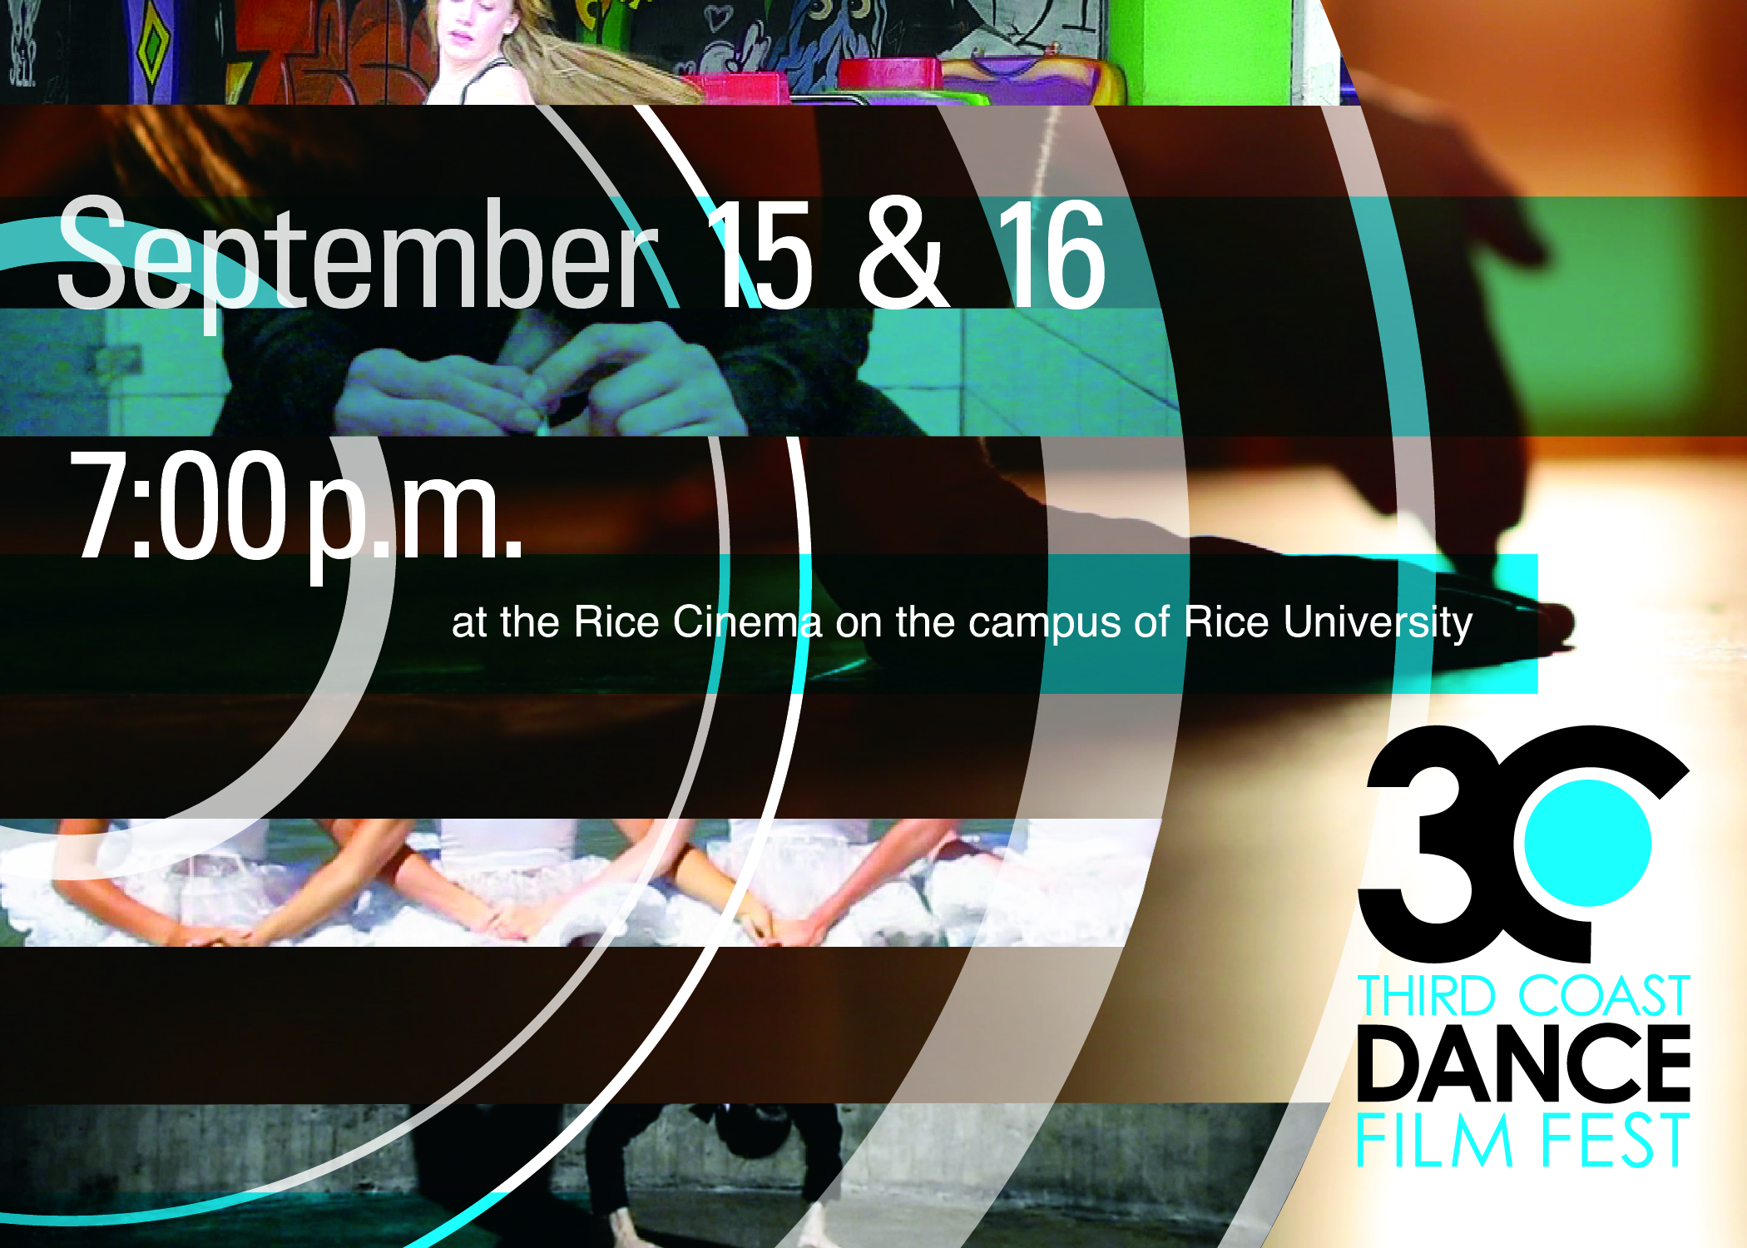

A special thank you to Charles Dove and the Rice University Cinema, Lydia Hance,
Raquel Kahn and all of the filmmakers.

2012 Third Coast Dance Film Festival Curators: Rosie Trump and Lydia Hance

http://thirdcoastdancefilmfestival.wordpress.com
thirdcoastdancefilmfest@gmail.com

2012 Third Coast Dance Film Festival Program A:

Another Good Morning, 2011 (USA)
Director/Choreographer/Performer: April Rose Burnam | Cinematography and music: Reed Burnam
Description: Another Good Morning captures the many outward and inward guises assumed by one woman as she moves throughout her daily routine. The film is meant to be a light-hearted yet poignant look into transition and everyday beauty.

Lebedi, 2011 (Russia)
Director/ Choreographer/ Cinemotographer: Anna Potapova | Performers: Lena Karuchenko, Tanya Makherova, Daria Zinovieva, Daria Simonova, Galya Kuzikhova | Sound: Tchaikovsky mix
Description: LEBEDI (THE SWANS) is a magic pop punk musical with the marvelous princesses of the swan lake. Great Tchaikovsky’s heiresses, drive beauties invite you to their fairy house.

The Door, 2011 (Australia)
Director / Cinema-photographer/ Editor/ Costume: Anya McKee | Choreographer: Anya Mckee (with collaboration from dancers Tahlia, Annabel, Linton & Katherine) | Dancers: Tahlia Russell, Annabel Saies, Linton Aberle, Katherine Gurr
Composer of Original Score: Tom Hogan
Description: How many times have you stood in its arches, this fickle pocket of space that stands between the room you’re leaving and the one that you’re going towards, yet refuses to belong to either.
Permission, 2012 (USA)
Choreographer/ Cinematorgrapher/ Performer: Lindsey Sarah Thompson | Sound credits include: Sarasate, Spanish Dance by Arnold; Rosé Arnautka by Steva Nikolič; normative by Terje Paulsen; Pinata Sonatta G# by U Can Unlearn Guitar
Description: permission was created in the aftermath of a break in. The ideas of personal space, ownership, voyeurism, intimacy and vulnerability gained new significance, new perspective.

Reins, 2012 (USA)
Directors: Geoffrey Ehrlich & Kelly Bartnik | Choreographer/Dancer: Kelly Bartnik | Cinematographer: Deborah Lohse
Costumes: Colleen Ehrlich | Music: Will Gilfillan | Editor: Geoffrey Ehrlich
Description: rein noun \ˈrān\ 1 : a strap fastened to a bit by which a rider or driver controls an animal - usually used in plural 2 : a : a restraining influence : check <kept a tight rein on the proceedings> b : controlling or guiding power - usually used in plural <the reins of government>

Transit , 2012 (USA)
Director: Jeff Curtis | Choreographers/ Dancers: Greg Catellier & Kristin O'Neal | Music: Kendall Simpson
Description: Transit is an exploration of distance, space, and relationships between two bodies and their observer.

For Water, 2012 (USA)
Director/Choreographer: Natalie Metzger | Composer/Cinematographer: Robert Allaire
Performers: Lisa Long, Anne C. Moore, Dewi Nurnaeny, Cherise Richards, Helda Yossiana
Description: For Water is inspired by the importance of water to the islands of Indonesia and to water-starved California. The film follows a pilgrimage of five spirits to a sacred place to perform their centennial ritual for water.

A Study in Ballet, 2012 (USA)
Producer/Director/Cinematographer: Lynn Lane | Choreography: Alisa Matthews/Lynn Lane | Dancer: Alisa Matthews
Description: A Study in Ballet is an hour long uninterrupted solo structured improvisational performance shot in time-lapse photography to simulate a windup ballerina in the studio.

Jazzland, 2012 (USA)
Director/Choreographer/Performer: Ashley Horn | Film Crew: Daniel Adame, Shanon Adams, Tad Nott
Original Score: Robert Pearson | Sound Engineer: Ryan Edwards
Description: Jazzland is a dance for camera piece filmed in the abandoned landscape of a New Orleans theme park flooded by Hurricane Katrina. An original score was created for the piece by improvisational pianist Robert Pearson.

EVENT, 2011 (Finland)
Director: Timo Wright | Choreogrpaher: Heli Meklin |Dancers: Jari Vuomajoki, Emilia Neuvonen, Laura Vesterinen, Esete Sutinen,Arttu Palmio, Elina Häyrynen, Anna Mustonen, Andrius Katinas
Descrption: Event is a independant spin-off piece from Heli Meklin's dance performance Simple Events.
What goes up, must come down.

Something For Myself , 2012 (USA)
Camera & Direction: Olive Bieringa and Otto Ramstad | Editor: Olive Bieringa
Music: Dark Dark Dark | Dancers: Gwen Bartholomay, Willa Bartholomay, Aubrey Donisch, Brittni Fillipek, Hope Grathwol, Camillle Horstmann, Elena Hansen, Gillian Leugers, Kari Olson, Sara Magnuson, Andrew Michel, Tona Rattigan-Green, Kina Paguyo-Macosko, Simone Richard, Avery Shoemaker, Megan Thimmesch, Ella Tomlinson, Annie Warnke
Description: Something for Myself is a collaboration between Minneapolis' Body Cartography Project and Young Dance Co. The film features 18 young dancers, ages 7-17.

Yo Creyera para Creer (I would believe in order to believe), 2011 (Spain)
Director: Chevi Muraday and Javier Cardenete | Choreographer: Chevi Muraday | Dancers: Carmen Ruiz, Chevi Muraday, Paloma Sáinz-Aja, Maximiliano Monte, Sara Manzanos |Music: David Rosenmann-Taub.
Editing: Javier Cardenete Description: Is life the cause of death, or death the cause of life?

